Thomas Reagan
c950

A. Algorithm Selection

The core algorithm in my program is the deliver_package function of the Delivery file. I would consider it to be a brute force / greedy approach to delivery with elements of divide and conquer in the presorting of the packages. Pseudocode:
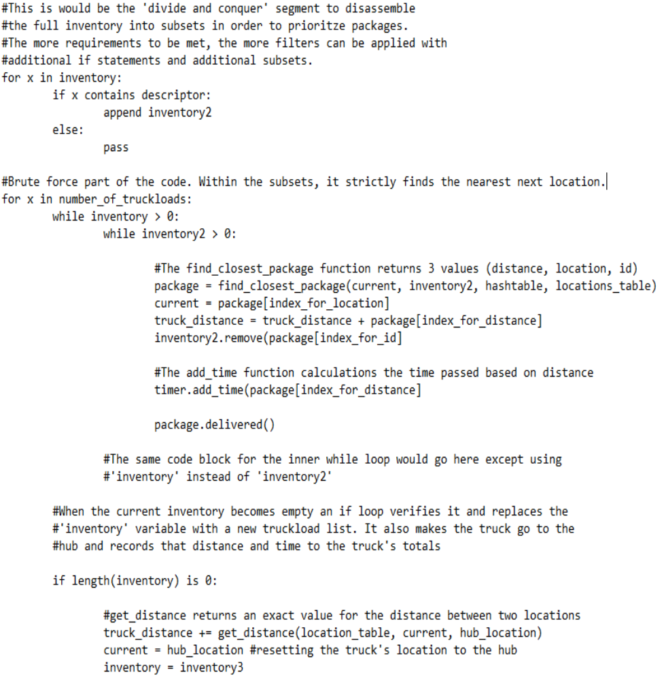

This part of the code handles the looping through the inventories while the sub-function handles the actual finding of the next nearest object:

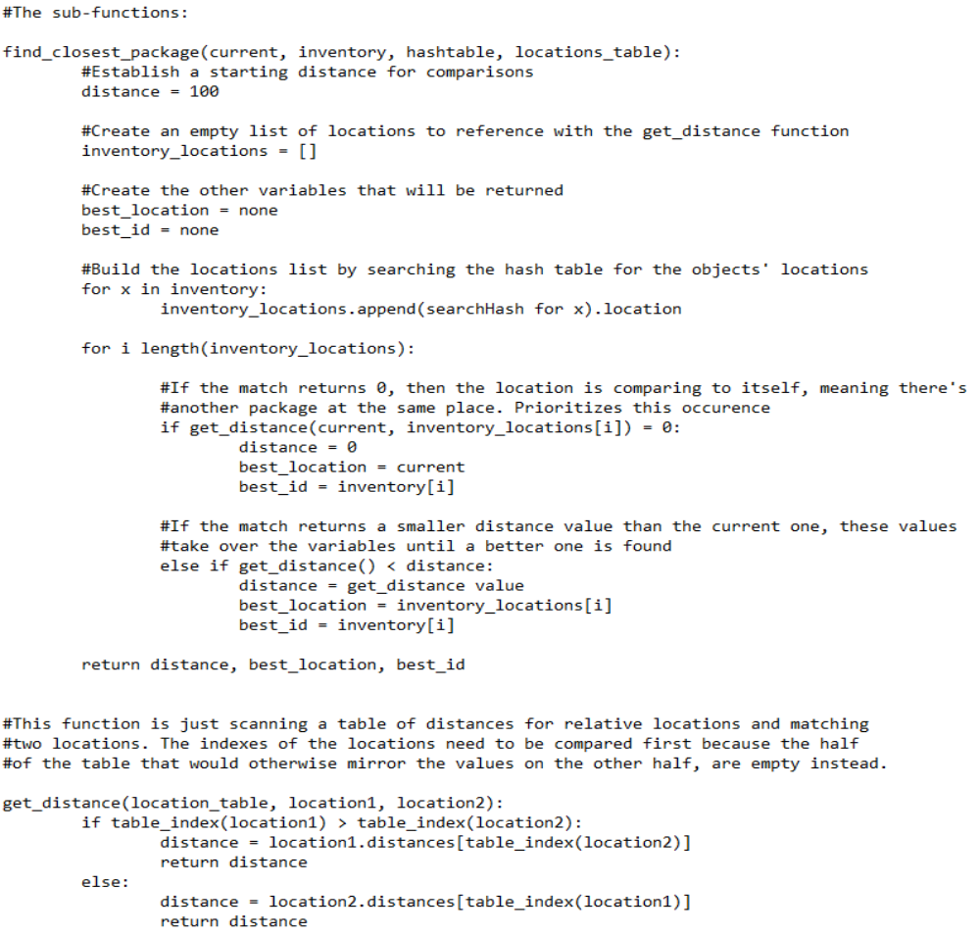

These sub-functions handle the actual searching process for next best location within the given inventory lists. The method used is a simple search for the lowest distance value using the 'current location' as a fixed point, and comparing it with a list of the possibilities through the use of a loop.

Complexity:

The get_distance function has a time complexity of O(1). It simply returns an exact value from the reference table.

The find_closest_package function is of time complexity O(n). As the inventory variable increases, the function's run time increases linearly as it still just performs a single search run through the list, finding the lowest value. The way this function overrides it's return variables with the best found values as it iterates through the list makes it a self-adjusting function. A quick way to increase the efficiency of what I've coded would be to simply add a break for the loop when it finds a zero instead of finishing the search.
The overall time complexity of the core deliver_packages algorithm is O(n^3). The outer loop dependent on the number of truckloads is O(n). The inner while loops are only dependent on the length of the truckload itself as the subsets are derived from that limit, so even if there are more than two subsets, the resulting complexity is still O(n). Then there's the embedded find_closest_package function which also has a complexity of O(n). Together these make O(n^3).

Self-Adjusting:

The self adjusting parts of the algorithm include the find_closest_package function as mentioned before as well as the ability to handle any number of truckloads with any number of keys, given the keys provided have a matching package in the manifest. The sorting part is also self-adjusting given the restriction types are consistent day to day with different manifests (this program only checks for certain key phrases and times, but more could be added easily if there was some kind of rule set for restriction descriptions in the package special notes.)

Other Options:

Another approach to this problem would have been to create a graph of the locations and using Djikstra's algorithm in combination with an inventory list to find an optimal overall path distance-wise for each truckload.

Why I Chose This Way:

I took the approach I did because it's straightforward and simple. Iterate through a list, find the best one, go there and remove it from the list, iterate again. The complexity is efficient which makes it scale well with larger lists, but it's definitely not optimal as far as obtaining the lowest possible mileage. It's possible that it can be given a set of packages with restrictions that force it to run back and forth across town inefficiently. But given the relatively small number of restrictions in this list of packages, this method is a reasonable solution to get under 140 total miles.

B1: Logic Comments

Comments are found throughout the code.

B2: Application of Programming Models

Python 3.7 and PyCharm CE were used to create this program. All of the package information and distance information are stored locally, so no communication protocol or defined interaction semantics were needed.

B3: Space-Time and Big-O

Comments are found throughout the code.

B4: Adaptability

Part of the code outside of the core algorithm is hard coded to make truckloads of length 16. That can easily be modified to a become a variable, and the core algorithm itself scales well with however large inventories may be when they are passed in. The primary weakness lies in how it handles priority. It simply scans for matching text and given that there is no pre-defined set of keywords that may be used in future package notes, the prioritization portion of the algorithm may well be useless. It's also clearly not the optimal solution for mileage as graph based options would likely be.

B5: Software Efficiency and Maintainability

The get_distance function has a time complexity of O(1). It simply returns an exact value from the reference table.
The find_closest_package function is of time complexity O(n). As the inventory variable increases, the function's run time increases linearly as it still just performs a single search run through the list, finding the lowest value. The way this function overrides it's return variables with the best found values as it iterates through the list makes it a self-adjusting function. A quick way to increase the efficiency of what I've coded would be to simply add a break for the loop when it finds a zero instead of finishing the search.
The overall time complexity of the core deliver_packages algorithm is O(n^3). The outer loop dependent on the number of truckloads is O(n). The inner while loops are only dependent on the length of the truckload itself as the subsets are derived from that limit, so even if there are more than two subsets, the resulting complexity is still O(n). Then there's the embedded find_closest_package function which also has a complexity of O(n). Together these make O(n^3).

The overall program is broken down into various class files as well as separate files for major functions. The division of these files with clear names to indication what they contain make it easy to understand at a glance. Variable names are made to be as clear as possible as well. Comments are provided for every major section of code to shortly explain its purpose.

B6: Self-Adjusting Data Structures

The hash table for the packages is a self-adjusting data structure. It has the ability to modified with the insertion or removal of objects. It can be coded to dynamically adapt its size upon new insertions or even just append new objects to a hashed location in the form of a chaining hash table.

C: Original Code

The code performs without error, given the user inputs acceptable values. All requirements are met as shown in the screenshots.

C1: Identification Information

First name, last name, and student ID are included in a comment at the top of every .py file.

C2: Process and Flow Comments

Comments are included throughout the code.

D: Data Structure
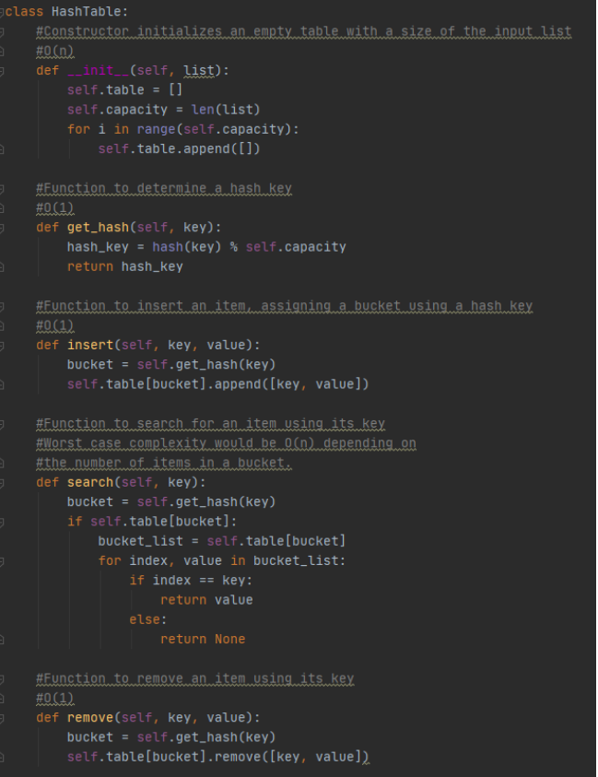
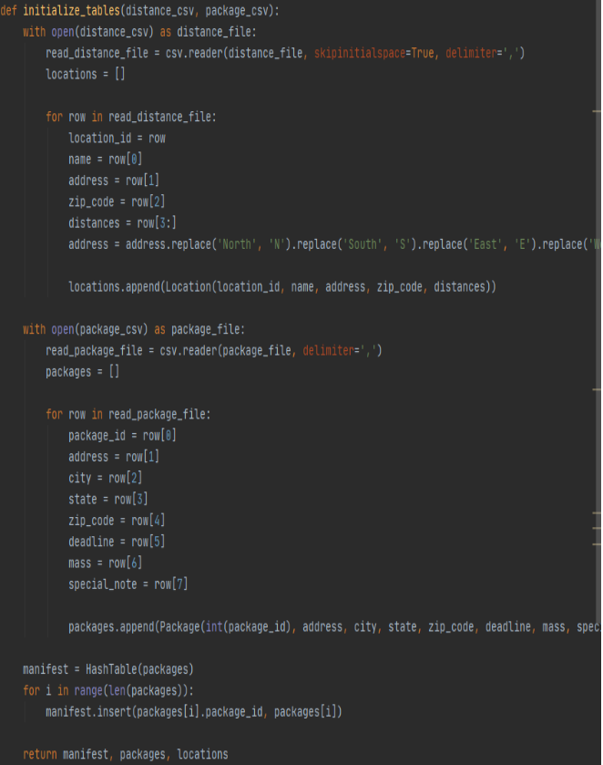

D1: Explanation of Data Structure:

The hash table acts as the manifest in this problem. It stores all of the package info and is referenced when any of that information needs to be used or changed. By creating a Package class, the all of the information read from the csv file can be stored within the needed number of those objects. This package list is then inserted into the hash table, using their respective package ID's as keys. With this setup, it's easy to build lists that will be used throughout the program, using information referenced in the manifest using keys. The search function is also used to maintain the status of each package, providing accurate information with regards to any address changes or delivery status updates.

E: Hash Table

See section D.

F: Look-Up Function

See sections D and G.

G: Interface
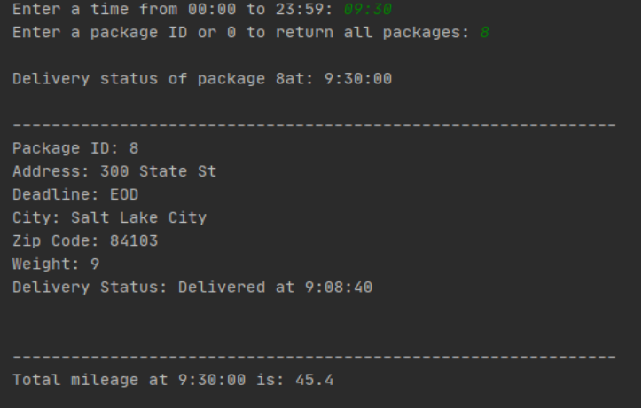

G1-G3: 1st, 2nd, and 3rd Status Checks

See “Screenshots” folder.

H: Screenshots of Code Execution

See “Screenshots” folder.

I1: Strengths of the Chosen Algorithm

This algorithm is efficient with a polynomial complexity to only the 3rd power, so it will scale reasonably well with longer lists. Its ability to handle variable input lengths without any loss of functionality is also a benefit of it. Whether the manifest contain more packages or the truckloads are larger, the core algorithm will handle them the same way.
Its also easily adjustable, particulary with regards to its prioritization portion. A programmer can alter the algorithm to more rigidly subdivide truckloads and then just add extra inner while loops for the priority lists.

I2: Verification of Algorithm

The screenshots for the 1pm (13:00) status check meets this requirement.

I3: Other Possible Algorithms

Another approach to this problem would have been to create a graph of the locations and using Djikstra's algorithm in combination with an inventory list to find an optimal overall path distance-wise for each truckload.
Another option would be fully investing in the divide and conquer approach to fully order the packages and then move the truck in the order of that list.

I3A: Algorithm Differences

The approach incorporating Djikstra's would be a more optimized, but more complex, approach to solving the solution. This method would predetermine the lowest distance route for the truckload as a whole instead of taking the packages one by one. The algorithm would still require some kind of prioritization system to meet the requirements; most likely a way of handling subsets after sorting, similar to what I did.
The divide and conquer approach would be more invested in strictly ordering the packages properly ahead of time. This approach's end result could vary greatly depending on the rigidity of the filtering process while subdividing the inventory. It would also seemingly not be very flexible since it would likely depend on a predetermined set of restriction possibilities, but we don't know enough about the fictional delivery company's policies to know if it's a good approach.

J: Different Approach

If I were to redo the project, I'd try to automate the truckload sorting process using a single function that takes the manifest and even the restrictions as input and outputs the truckloads. What's implemented now is more of a manual process. Some of it is automated, but its tailored for the particular package list that's given.

K1: Verification of Data Structure

The screenshots verify the functionality of the code and the meeting of all requirements as outlined. The screenshots for the test at 1pm (13:00) verify that all package requirements as well as the total mileage requirements are met. The rest of the screenshots verify other aspects of the requirements such as returning information of a package at a specific time.

K1A: Efficiency

The hash table used in this program consists of package objects assigned to buckets with a key value that matches a respective package. For simplicity, in this implementation, each package has its own bucket since the table is initialized with a size that's equal to the size of the list created from the source package data file. To even further simplify the implementation, the key created for each object matches that object's package ID.
The benefit of using a hash table is in its efficiency. Instead of iteration through a list when needing to reference a particular package, you can instead use the search function, with a key input, to immediately return the wanted result. In this implementation, with a one-to-one object to bucket ratio, a search results in a O(1) time complexity. Technically, a chaining hash table would be O(n) if used, but it's still more efficient then iteration through an list that could vary greatly in length.

KB: Overhead

Time complexity for a hash table is typically more efficient for referencing specific objects compared to other data structures as explained in the previous section. Given that the entirety of this code and the data it references is stored on a local machine, bandwidth isn't relevant here. Memory implications of using a hash table could actually be negative, however. Empty buckets result in wasted memory.

K1C: Implications

My implementation of the hash table initializes the size to the list of package objects created from the data read in from the csv file. Beyond initially inserting those packages in a one-to-one bucket to object ratio when creating the hash table, additional inserts would turn it into a chaining hash table as the new object would be assigned to a bucket that already has a package, appending a bucket list. I could initialize the size to be a static number to accommodate a higher number of packages or implement some code to increase the size by one any time a new object is inserted.
The implications of inserting an extra object wouldn't affect the algorithm as it is. The key values used throughout the program would still return the proper objects from the hash table.

K2: Other Data Structures

The list of requirements could bet met by simply using object arrays / lists instead of incorporating a hash table. Simply iterate through the object array anytime something it contains needs to be referenced. Speed would be the downside.
Another option would be to create a graph and weighted edges using the data given and then an algorithm, such as Djikstra's, to navigate that graph. The vertices themselves would be location objects that contain as a property a list of packages. Sort of the inverse of my implementation of package objects that have a location attribute. You would be able to then reference the vertices' package information to retrieve whatever information is needed.

K2A: Data Structures Differences

See K2.

L: Sources

N/A

M: Professional Communication

Comments throughout code as well as this document are hopefully well communicated.

